# **List of Parts**

Arduino Nano 33 BLE Sense- <https://www.amazon.com/Nano-BLE-Sense-Rev2-ABX00069/dp/B0BQHXVSGM/ref=asc_df_B0BQHXVSGM?mcid=f8a43e1b67ad3a9aacdbfa9cb290e320&hvocijid=15449847686793993850-B0BQHXVSGM-&hvexpln=73&tag=hyprod-20&linkCode=df0&hvadid=721245378154&hvpos=&hvnetw=g&hvrand=15449847686793993850&hvpone=&hvptwo=&hvqmt=&hvdev=c&hvdvcmdl=&hvlocint=&hvlocphy=9060451&hvtargid=pla-2281435179338&psc=1>

TP4056 LiPo Charging Module- <https://www.amazon.com/HiLetgo-Lithium-Charging-Protection-Functions/dp/B07PKND8KG/ref=asc_df_B07PKND8KG?mcid=582532d88b30334da0eb72382cf0d57a&hvocijid=806802862098911036-B07PKND8KG-&hvexpln=73&tag=hyprod-20&linkCode=df0&hvadid=721245378154&hvpos=&hvnetw=g&hvrand=806802862098911036&hvpone=&hvptwo=&hvqmt=&hvdev=c&hvdvcmdl=&hvlocint=&hvlocphy=9060451&hvtargid=pla-2281435178618&psc=1>

Breadboard- <https://www.amazon.com/ELEGOO-tie-points-breadboard-Arduino-Jumper/dp/B01EV640I6>

Jumper Wires - <https://www.amazon.com/California-JOS-Breadboard-Optional-Multicolored/dp/B0BRTJXND9/ref=asc_df_B0BRTJXND9?mcid=c0c5869d519b33f28fdb4e6a5bfc68e5&hvocijid=11941716491220606205-B0BRTJXND9-&hvexpln=73&tag=hyprod-20&linkCode=df0&hvadid=721245378154&hvpos=&hvnetw=g&hvrand=11941716491220606205&hvpone=&hvptwo=&hvqmt=&hvdev=c&hvdvcmdl=&hvlocint=&hvlocphy=9060451&hvtargid=pla-2281435178298&psc=1>

Electrical Tape- <https://www.amazon.com/Duck-373447-Professional-Electrical-0-75-Inch/dp/B007JSGNWU/ref=asc_df_B007JSGNWU?mcid=51d29eba7d3235b8a70ea6387b8c3970&hvocijid=15079179560037877208-B007JSGNWU-&hvexpln=73&tag=hyprod-20&linkCode=df0&hvadid=721245378154&hvpos=&hvnetw=g&hvrand=15079179560037877208&hvpone=&hvptwo=&hvqmt=&hvdev=c&hvdvcmdl=&hvlocint=&hvlocphy=9060451&hvtargid=pla-2281435179338&th=1>

Multimeter- <https://www.amazon.com/AstroAI-Digital-Multimeter-Voltage-Tester/dp/B01ISAMUA6?source=ps-sl-shoppingads-lpcontext&ref_=fplfs&smid=A2NOFZGOKNP3PJ&gQT=1&th=1>

3.7V LiPo Battery (500–1000mAh with JST connector)- <https://www.amazon.com/1000mAh-battery-Rechargeable-Lithium-Connector/dp/B07BTV3W87/ref=sr_1_1_sspa?crid=2UMOO02080W7G&dib=eyJ2IjoiMSJ9.Ygr3Lni9SNbjOgH-7HHshvzwe0sHB_e3yOiPAwbQ3ez9P9LPHp6fSyKPl2NzcWjk_3wUaSeqipwHjxYAZxPsTjcHFEJi4HNjFbPAjggJeqeDbbU5utYuoaBqztzAs7cXQYwzXbIJHJijOXL-1OV9G-dGNpS_v4t74L25OWCahyesE9CGd89tpKL5LyKQO8HIddEjiEjfZdWl9bzImdzK5xovD2fbGFAZd9ABYoET1Upe3SZs2qlKzHGX7afUWuvTR5WUblnv2P9VuzmNC9uHZ5sivRvjztilnR-iUjlMWlk.7BX4mb8LxGq0Vb3b4MLlYnnVTeB31CUJ2zSSqR99CC8&dib_tag=se&keywords=3.7v+lipo+1000mah&qid=1737092727&sprefix=3.7v+lipo+1%2Caps%2C141&sr=8-1-spons&sp_csd=d2lkZ2V0TmFtZT1zcF9hdGY&psc=1>

MCP1700 for 3.7v to 3.3v- <https://www.amazon.com/MCP1700-3302E-MCP1700-Microchip-Voltage-Regulator/dp/B084LBDPC7/ref=asc_df_B084LBDPC7?mcid=3f9cb1325b2e35b78a7eb002f2a4c20f&hvocijid=5852398271468258187-B084LBDPC7-&hvexpln=73&tag=hyprod-20&linkCode=df0&hvadid=721245378154&hvpos=&hvnetw=g&hvrand=5852398271468258187&hvpone=&hvptwo=&hvqmt=&hvdev=c&hvdvcmdl=&hvlocint=&hvlocphy=9016852&hvtargid=pla-2281435176898&psc=1>

1µF Ceramic Capacitor- <https://www.amazon.com/Cermant-Multilayer-Monolithic-Ceramic-Capacitor/dp/B0D2H87Q32/ref=sr_1_4?dib=eyJ2IjoiMSJ9.nl4sOcJ7qgTAqrB0l60YMNaCeAbs2C1PFsr-ElGbAcNqnCBNma9q-HzHP1wHeJNeeQg00DDlp-D0RyDvv9xLzzsR2a1qqYRV6ZL-7FwQCWkoslHwtcNkfLcpvVqfCO1nudr6LwkuRkiCOwC8Zf2rQ3rYDpay6BfvSKQOSIEwqaveSa9KjNJA0Qgm1hsp1GwejCYuUNalV23DqNjFX5HVzbvvwAsvYwdNNhbdTJ9J0b0.xAzb9fJsREk8Kf9PiBdszwn-OhavTOqiqNyo4-Ybkt4&dib_tag=se&keywords=ceramic%2Bcapacitor%2B1uf&qid=1737093679&sr=8-4&th=1>

JST Connector Kit- <https://www.amazon.com/300PCS-2-54mm-Connector-Housing-Adapter/dp/B0CB94MZ3M?th=1>

# **How to Connect**

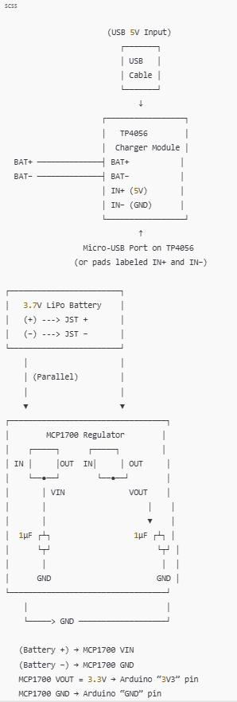

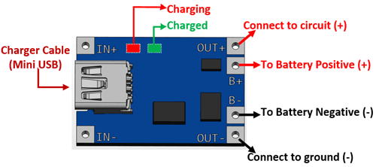

1. The **LiPo battery** connects to the **TP4056** at **BAT+** and **BAT–**.
2. **Also** from those same battery lines (i.e., “in parallel”), route the positive line to **MCP1700 VIN** and the negative line to **MCP1700 GND**.
3. The **MCP1700** outputs a regulated 3.3 V, which you feed into the **3V3 pin** on the Arduino Nano 33 BLE Sense.
4. The **GND** pin on the MCP1700 ties back to the battery negative, which also goes to the Arduino **GND**.

## **Where the Capacitors Go**

* **One 1 µF capacitor** between the **MCP1700 “VIN” pin** and **GND**.
* **One 1 µF capacitor** between the **MCP1700 “VOUT” pin** and **GND**.

These ensure the regulator stays stable and smooths out any small voltage fluctuations.

## **Breadboard Arrangement (Example)**

A possible way to place these on a breadboard:

1. **Place the MCP1700** so that its **VIN**, **VOUT**, and **GND** pins each align with different rows.
2. In the same row as **VIN**, insert one side of a **1 µF capacitor**. The other side of that capacitor goes to a **GND row** on the breadboard.
3. In the same row as **VOUT**, insert your second **1 µF capacitor**. The other side goes to the **GND row** as well.
4. Connect the **LiPo battery “+”** line (also from **TP4056 BAT+**) to the **VIN** row; battery “–” to the breadboard’s **GND** row.
5. Jumper **MCP1700 VOUT** to the Arduino **3V3** pin, and connect the breadboard **GND** row to the Arduino **GND** pin.

## **Tips for a Clean Setup**

* **Use JST connectors** to avoid reversed polarity:
  + The LiPo will likely already have a JST‐PH connector.
  + Make sure the TP4056 module’s JST socket (if present) matches your battery’s polarity.
* **Insulation**: If any exposed pins or wires might touch each other, wrap them with **electrical tape** or use heat‐shrink tubing to avoid shorts.
* **Multimeter**: Always verify the regulated output is around **3.3 V** before plugging into your Arduino.
* **Mounting**: For a finished prototype, you can secure the battery, the modules, and the regulator onto something sturdy, or solder them onto perfboard.

By following this arrangement, your Arduino Nano 33 BLE Sense will safely receive a stable 3.3 V supply from the LiPo battery (while being able to recharge that battery through the TP4056).

